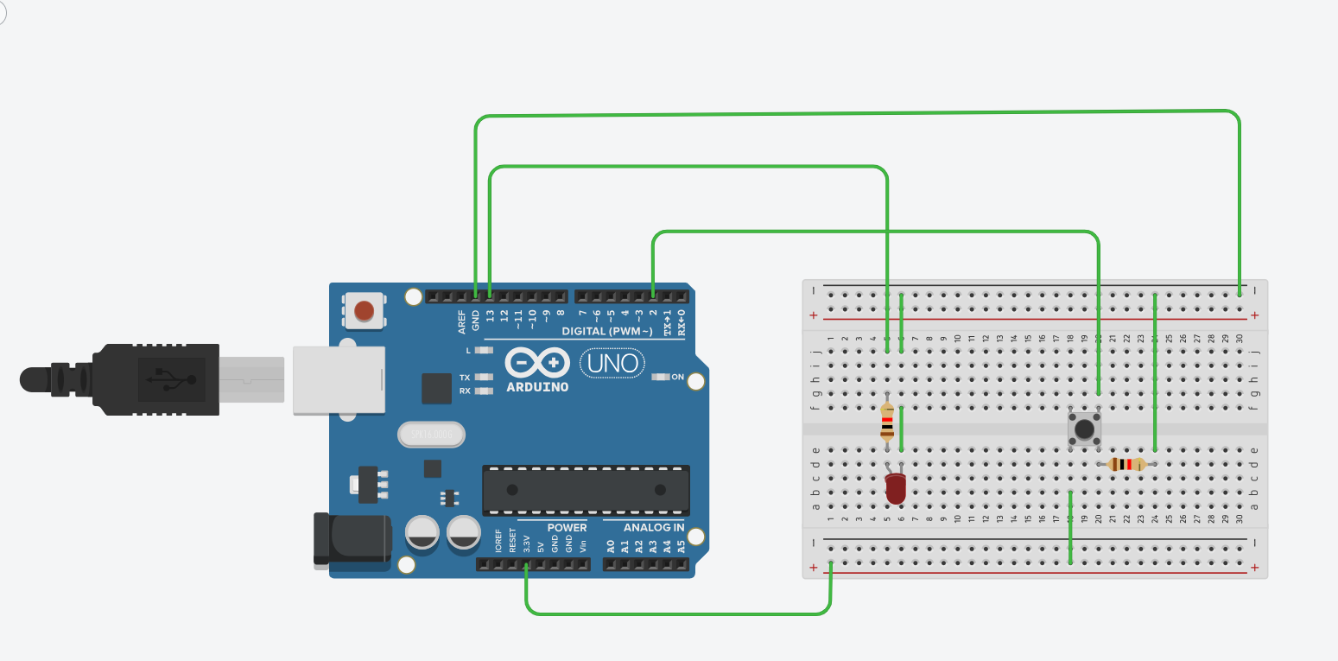
CODE:
int led = 13;
int pushButton = 2;

void setup()
{
Serial.begin(9600);
pinMode(pushButton, INPUT);
pinMode(led, OUTPUT);
}

void loop()
{
int buttonState = digitalRead(pushButton);
Serial.println(buttonState);
if (buttonState == 1)
{
digitalWrite(led, HIGH);
}
else
{

digitalWrite(led, LOW);
}
delay(1);
}

